**Project Report**

**1. Introduction:**

1.1 Overview: A document containing a certified statement especially as to the truth of something.

1.2 Purpose: to verify their legitimacy and competence to perform a job.

2. Problem Definition & Design Thinking:

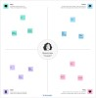2.1 Empathy Map:

2.2 Ideation & Brainstorming:

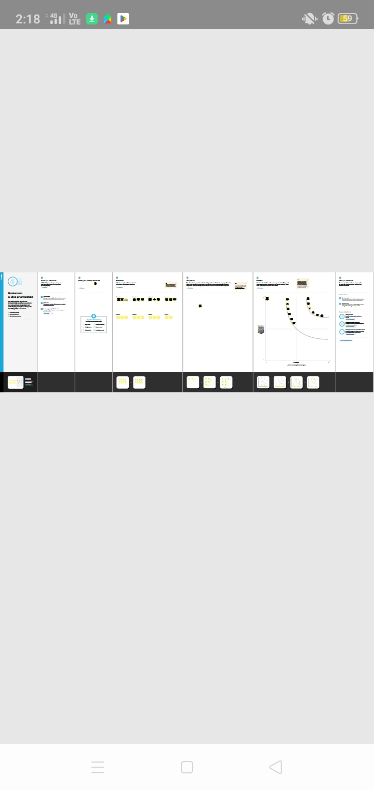

3. Result:

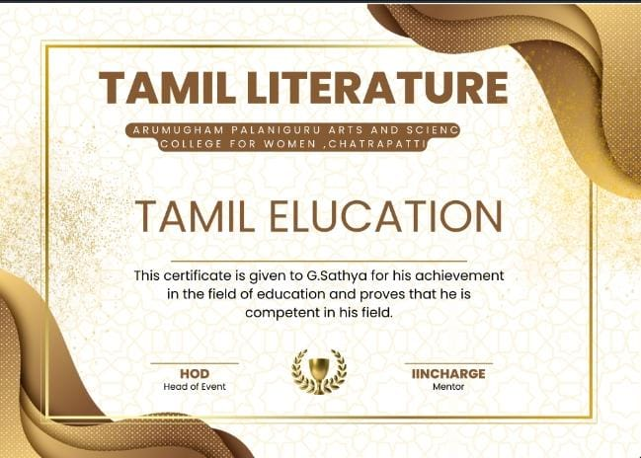

4. conclusion:

One of the most significant benefits of canva is the unlimited access to premium templetes and assets . In that we took certificate templetes .cerficate to make memories all around the world. Certificate is very useful for our career so all of you should participate the events.